Patient selection: Identify appropriate patients

Suggested wound selection criteria:

PICO sNPWT System has been shown to be capable of managing low to moderate exudate, and deliver nominal -80mmHg therapeutic negative pressure in large wounds of depths up to 4.5cm when used with an appropriate NPWT filler as demonstrated in vitro1

- Wound >6 weeks in duration – wound has reduced in area by <10% per week over previous 4 weeks
- Ensure wound bed is prepared for NPWT
- If wound is clinically infected consider antimicrobial before PICO sNPWT therapy

Weekly wound assessment
- Use simple length and width measures for area
- Change in exudate levels
- Ensure wound bed is less than 20% thin slough
- Change in pain levels
- Refer to TVN team for guidance
Email: Shropcom.tissueviability@nhs.net
Tel: 01952 670 925

- If VLU, ABPI confirmed as >0.8 and <1.3
- None of the PICO sNPWT contraindications for negative pressure apply

Week 1: Apply PICO sNPWT

Week 2: reassess and review wound

PICO Pump can be used with or without fillers
A full assessment of the wound is recommended before considering whether it is appropriate to use a wound filler or to apply the PICO sNPWT dressing directly to the wound.
Wounds greater than 0.5cm (1/4in) in depth are likely to require a foam or gauze negative pressure wound therapy filler to ensure adequate treatment of all the wound surfaces. Wounds greater than 2cm (3/4in) in depth must be treated with the use of a filler along with the PICO system to ensure adequate contact with the wound.

Wounds types under 2cm that the use of a filler would be appropriate:
  - The wound bed is uneven
  - There is undermining
  - The wound is a sinus

Uneven wound bed

Undermining Sinus
PICO sNPWT dressing kits
PICO 7 sNPWT
and PICO 14 sNPWT are available in 2 x dressings kits and multipacks for all sizes

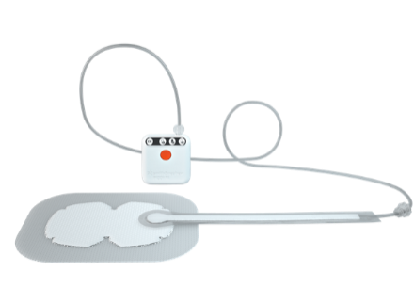
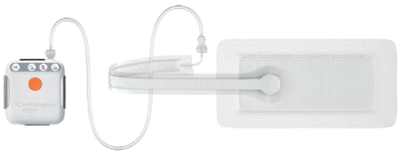
PICO7 sNPWT
PICO 14 sNPWT
For more information please contact:
Tissue Viability Service by email on: Shropcom.tissueviability@nhs.net
Or Tel: 01952 670 925

Dressing | Dressing size
10cm x 20cm
 | 10cm x 30cm
 | 10cm x 40cm
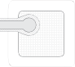 | 15cm x 15cm
 | 15cm x 20cm
 | 15cm x 30cm
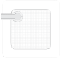 | 20cm x 20cm
 | 25cm x 25cm
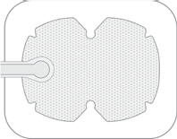 | Mutisite small 15cm x 20cm
 | Mutisite large 20cm x 25cm

Non-responder STOP PICO sNPWT
No significant improvement in granulation tissue quality/quantity, static or increased in size
Refer to TVN for guidance

Good responder

PICO sNPWT contraindications
The use of PICO sNPWT is contraindicated in the presence of:
- Patients with malignancy in the wound bed or margins of the wound (except in palliative care to enhance quality of life)
- Previously confirmed and untreated osteomyelitis
- Non-enteric and unexplored fistulas
- Necrotic tissue with eschar present
- Exposed arteries, veins, nerves or organs
- Exposed anastomotic sites
PICO sNPWT should not be used for the purpose of:
- Emergency airway aspiration
- Pleural, mediastinal or chest tube drainage
- Surgical suction
Created by SCHT TVN Team Version 1 July 2021 Approved by Area Prescribing Committee August 2021 Review September 2023
-Wound reduced in area
-Increase in granulation tissue
-Decrease in wound size
Use clinical judgement to determine whether PICO sNPWT treatment should be continued on a week-by-week basis and refer to TVN for guidance

Considerations for PICO sNPWT use
Patient suitability
Is PICO sNPWT a suitable treatment for the patient being considered?
- Will the patient be concordant with the therapy?
- Will the patient remove and/or interfere with the dressing and/or device?
- Will PICO be acceptable to the patient?

Wound site
Is the wound location suitable for treatment with PICO sNPWT?
- Avoid sites with pins and/or external fixation
- Will it be possible to achieve and maintain a seal?
- Can the port be located in an area which will minimise the risk of pressure damage?
- Consider routing of tubing to avoid risks of pressure damage and entanglement
- Consider proximity of stoma sites
- Consider application technique over joints
Magnet warning
The PICO pump contains a magnet. Keep the PICO sNPWT pump at least 4” (10cm) away from other medical devices at all times. Failure to do so can cause the other medical device to fail which can result in serious harm including death

References:
1. Smith & Nephew 9 November 2018. Evidence Outcomes Report: The Review Of Evidence Supporting The Use Of PICO In Wounds ≥2cm In Depth. Internal Report. EO.AWM.PCS230.001.V2
2. Dowsett, C; Recommendations for the use of negative pressure wound therapy, Wounds UK, Vol 8, No 2, 2012
3. Kirsner R, Dove C, Reyzelman A, Vayser D, Jaimes H. A prospective, randomized, controlled clinical trial on the efficacy of a single-use negative pressure wound therapy system, compared to traditional negative pressure wound therapy in the treatment of chronic ulcers of the lower extremities. Wound Repair Regen. 2019;27(5):519-529

References:
1. Smith & Nephew 9 November 2018. Evidence Outcomes Report: The Review Of Evidence Supporting The Use Of PICO In Wounds ≥2cm In Depth. Internal Report. EO.AWM.PCS230.001.V2
2. Dowsett, C; Recommendations for the use of negative pressure wound therapy, Wounds UK, Vol 8, No 2, 2012
3. Kirsner R, Dove C, Reyzelman A, Vayser D, Jaimes H. A prospective, randomized, controlled clinical trial on the efficacy of a single-use negative pressure wound therapy system, compared to traditional negative pressure wound therapy in the treatment of chronic ulcers of the lower extremities. Wound Repair Regen. 2019;27(5):519-529

