PICO Single Use Negative Pressure Wound Therapy (sNPWT): Step-Down
Consideration 1. Exudate levels:
RENASYS TOUCH is in place and the wound is not oozing more than 300mls in a week or NPWT is required and wound exudate is estimated not to exceed 300mls per week
NO
Due to the high amount of exudate PICO sNPWT is not currently suitable for this wound. RENASYS◊ TOUCH may be more appropriate NPWT option.
YES
Review Weekly
Consideration 2. Wound area: Will the area of the wound fit under one of the 10 PICO dressing options?
NO
PICO sNPWT is not currently suitable for this wound.
RENASYS TOUCH may be a more appropriate NPWT option.
YES
Refer to TVN team for guidance Email: Shropcom.tissueviability@nhs.net
Phone: 01952 670 925
Review weekly or contact TVN team for guidance
Consideration 3. Is a wound filler required: Is the depth under 0.5cm?
NO
If the wound depth is 0.5-4.5cm consider the use of a filler to ensure that negative pressure therapy reaches all surfaces
of the wound cavity.
Especially if the wound bed is: Uneven, undermining or a sinus wound. (Please refer to the guidance on the right-hand side)
YES
PICO sNPWT is appropriate for this wound

PICO sNPWT System has been shown to be capable of managing low to moderate exudate and deliver nominal -80mmHg therapeutic negative pressure in large wounds of depths up to 4.5cm when used with an appropriate NPWT filler as demonstrated in vitro1

PICO Pump can be used with or without fillers

A full assessment of the wound is recommended before considering whether it is appropriate to use a wound filler or to apply the PICO sNPWT dressing directly to the wound.
Wounds greater than 0.5cm (1/4in) in depth are likely to require a foam or gauze negative pressure wound therapy filler to ensure adequate treatment of all the wound surfaces. Wounds greater than 2cm (3/4in) in depth must be treated with the use of a filler along with the PICO system to ensure adequate contact with the wound.

Wounds types under 2cm that the use of a filler would be appropriate:

The wound bed is uneven
- There is undermining

The wound is a sinus

Uneven wound bed

Undermining Sinus

PICO sNPWT dressing kits
PICO 7 sNPWT
and PICO 14 sNPWT are available in 2 x dressings kits and multipacks for all sizes
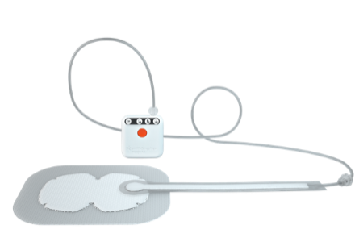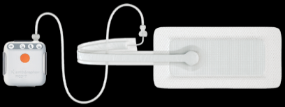
Considerations for PICO sNPWT use
Patient suitability
Is PICO sNPWT a suitable treatment for the patient being considered?
- Will the patient be concordant with the therapy?
- Will the patient remove and/or interfere with the dressing and/or device?
- Will PICO be acceptable to the patient?

Wound site
Is the wound location suitable for treatment with PICO sNPWT?
- Avoid sites with pins and/or external fixation
- Will it be possible to achieve and maintain a seal?
- Can the port be located in an area which will minimise the risk of pressure damage?
- Consider routing of tubing to avoid risks of pressure damage and entanglement
- Consider proximity of stoma sites
- Consider application technique over joints
Magnet warning
The PICO pump contains a magnet. Keep the PICO sNPWT pump at least 4” (10cm) away
from other medical devices at all times. Failure to do so can cause the other medical
device to fail which can result in serious harm including death

PICO sNPWT contraindications

The use of PICO sNPWT is contraindicated in the presence of:
- Patients with malignancy in the wound bed or margins of the wound (except in palliative care to enhance quality of life)
- Previously confirmed and untreated osteomyelitis
- Non-enteric and unexplored fistulas
- Necrotic tissue with eschar present
- Exposed arteries, veins, nerves or organs
- Exposed anastomotic sites
PICO sNPWT should not be used for the purpose of:
- Emergency airway aspiration
- Pleural, mediastinal or chest tube drainage
- Surgical suction
PICO7 sNPWT
PICO 14 sNPWT
For more information please contact: Tissue Viability Service Shropcom.tissueviability@nhs.net

Tel: 01952 670 925
Dressing | Dressing size
10cm x 20cm
 | 10cm x 30cm
 | 10cm x 40cm
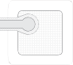 | 15cm x 15cm
 | 15cm x 20cm
 | 15cm x 30cm
 | 20cm x 20cm
 | 25cm x 25cm
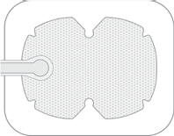 | Multisite small 15cm x 20cm
 | Multisite large 20cm x 25cm

References: 1. Smith & Nephew 9 November 2018. Evidence Outcomes Report: The Review Of Evidence Supporting The Use Of PICO In Wounds ≥2cm In Depth. Internal Report. EO.AWM.PCS230.001.v2
2. Dowsett et al, Use of PICO™ to improve clinical and economic outcomes in hard-to-heal wounds. Wounds International 2017 | Vol 8 Issue 2

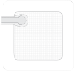
Created by TVN Service SCHT Version 1 July 2021
Approved by Area Prescribing Committee August 2021 Review September 2023

