

Services for Children & Young People

Occupational Therapy

Ideas to calm your child
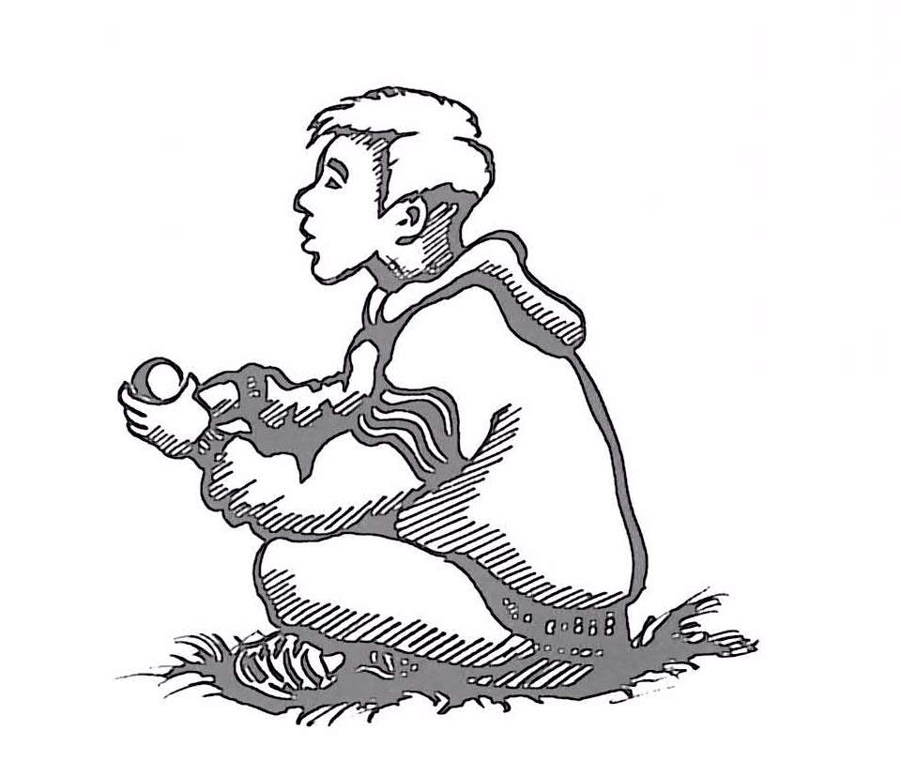

These activities may help your child to slow down and allow him to improve his ability to sit in a more controlled manner and pay more attention to what is happening around him.

- Encourage your child to place palms of hands on the top of his head and press down (this can be described as squashing himself into the floor) with even pressure for the count of 25. Repeat twice.

- Using a ball – ideally a foam or squashy one – the child holds this between two flat hands in front of his chest. Squash the ball as hard as possible to flatten it and hold for the count of 50. Repeat once.

- Encourage your child to lie down on his/ her tummy, then roll an inflated ball (such as a Pilates/ Therapy ball or even just a football) down body, starting from the shoulders. If your child likes this, put a little pressure down through the ball – ensure you check with child whether he/she wants you to press more lightly or more firmly. Some children enjoy this while wrapped like a sausage in a blanket, a bit like being swaddled – only do this if child likes it, has the physical ability and strength to be able to easily get out independently and his/her head is NEVER covered

- Using a skipping rope or piece of garden hose, two people sit on the floor with legs out straight and feet touching. Hold the rope firmly then do controlled pull and push movements, like a rowing exercise.

- Using big cushions, duvet, blanket or pile of coats, allow the child to wrap himself up in these as he needs to. He may also like some steady gentle pressure on the cushions for a short time.

- Push against wall or down on desk for count of 20.

- Push against parent hands outstretched, adult to vary force and direction of push slightly to facilitate change of body position.

- Big bear hugs all round.

- Build a den out of your sofa cushions, incorporate lots of pulling and pushing

- In rough and tumble play, incorporate lots of gentle ‘squashing’ such as making it a little harder for your child to crawl out from under a cushion, or to wriggle out of your arms – try using a Pilates or even just a football to gently squash your child with – encourage him/ her to squash you back.

- Try an indoor ‘sack swing’ – type in ‘children’s indoor swings’ on your internet search engine. Look for a swing which provides a ‘cocoon’ type environment where your child can safely snuggle up inside while you gently push the swing to and fro

- When the weather is nice and if you have a suitable outdoor space, try a garden hammock. Opt for the large fabric types which fold/ flop around you once in.

- Consider the bedroom environment in terms of promoting sleep – experiment with dim/ calming lighting, different weights of blankets/ blankets tucked in/ mummy sleeping bags – see what your child likes best. Some children like the feel of several blankets placed over their lower half, with extra pillows piled on top to provide gentle pressure – others prefer to feel snuggled and enclosed in a camping mummy-style sleeping bag, some children like to be tucked in very firmly, others to have nothing covering them at all.

- Also consider using sound to help calm – try sounds of nature such as rain, birdsong, ocean waves and/ or specialist sleep promoting soundtracks (if you subscribe to a music streaming service you should find lots of different options under ‘sleep’)

- Consider providing a sensory calm place in the home/ school environment – such as a pop-up tent covered with a blanket, with large, heavy cushions and soft blankets inside and some kind of gentle, diffused lighting – a child-safe lava lamp or suitable glow toy (slow light-changing ‘stones’ for example) might be better than fairy lights which can stimulate the visual system for some children

All of these activities should be carried out under adult supervision, at a slow and steady pace. In school the child could also focus on these more easily in a small room with minimal distraction. This is not always as manageable in school as in the child’s own home but it is worth trying to do what is possible.

