PLEASE READ ALL OF THIS INFORMATION CAREFULLY
Blood test type | How to book an appointment | Where to go for the appointment
All blood tests  (Not consultant from Hospital or local clinic) | Online Booking available at  https://www.shropscommunityhealth.nhs.uk/childrens-phlebotomy-service  By telephone  01743 450855 option 1  This is an answerphone service so please leave the details asked for in a clear voice. Name, NHS number (preferred) or date of birth and contact number.  You will be contacted within 2 working days to book an appointment | Donnington Medical Practice  Health Centre, Wrekin Drive,  Donnington,  Telford, TF2 8EA

Write the date and time here as a reminder:
Appointment Date …………..……….…. Time …….………..

What you need to do on the day of the appointment

Attending the clinic

- Children must attend with a parent or carer who has parental responsibility. If a parent is unable to
attend and the child is being brought by another carer then there must be a letter of consent from the parent.

- Blood test request forms need to be completed by the requesting Doctor and brought with you to the appointment. No blood form, no test

- Anaesthetic cream will be prescribed for your by your General Practitioner (GP) at the time they decide with you that a blood test is needed
The cream needs to be applied on the inside or crook of the elbow at least 45 minutes prior to the appointment time.

- Please ensure children are warm and have had plenty to drink prior to arriving for the appointment

For fasting blood tests children must not eat or drink (apart from water) for a minimum of 8 to 10 hours before the test. When the appointment is made with the phlebotomy service you will need to request an early morning appointment for fasting blood tests between 9am to 10am. Later appointments are not suitable, especially for young children.

Use of anaesthetic cream 5% (EMLA)

In order to reduce the pain associated with blood tests it is advisable for children to have an application of local anaesthetic cream to the site from which blood is to be taken. Please read the instructions below:

Apply the EMLA cream 45 minutes before the appointment time

- Apply the EMLA cream, in a blob to the inside surfaces of both elbows (inside fold of the arm) over the vein if possible. Use half a tube for each arm. DO NOT RUB IN.

- Cover the areas with the film dressing if provided or loosely wrap with cling

- Leave the cream on for 45 minutes to allow it to take effect.

Please note these application instructions may differ from the product information leaflet enclosed.

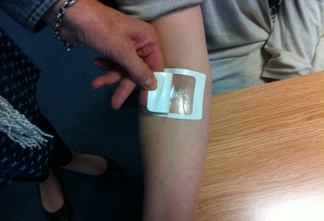

Cream should not be applied if

Your child has known allergies to local anaesthetic.
Your child’s skin is broken.

Possible side effects of the cream

Redness, local swelling, itchiness, rarely blisters.

Procedure
When you arrive for the appointment you (the parent or person with parental responsibility) will be asked to sign a consent form for the blood test to be completed.

You are also signing to confirm that you understand why the blood test is needed and that the procedure may involve; appropriate holding, pain relief methods and that possible side effects have been explained.

Once the anaesthetic cream is effective, the dressing will be removed and the area cleansed. You will be encouraged to stay with your child, please feel free to inform the staff if this would be a problem for you.

Results
Results will go to the Surgery that requested the test. Results should be available from your surgery within a week.

If you have any questions please ask when you phone for an appointment or when you arrive for the appointment. Thank you.

