**Indwelling Urinary Catheter Card**

**REASON FOR CATHETERISATION:**

* **Retention – state reason for retention (e.g. spinal injury, neurological**

**illness, benign prostatic hyperplasia/other)…………………………………….**

* **Intractable urinary incontinence**

Date of initial insertion ……… / ….…… / ……….

Location of patient at initial insertion e.g. hospital …………………………

Site: suprapubic / urethral Size of catheter:……...ch

Type of catheter: 28 days PTFE / 12 week all silicone/hydrogel

Length of catheter: female/standard

**DATE OF PLANNED TRIAL WITHOUT CATHETER: ……… / ……… / ……….**

**Indwelling Urinary Catheter Card**

**REASON FOR CATHETERISATION:**

* **Retention – state reason for retention (e.g. spinal injury, neurological**

**illness, benign prostatic hyperplasia/other)……………………………………..**

* **Intractable urinary incontinence**

Date of initial insertion ……… / ……… / ……….

Location of patient at initial insertion e.g. hospital ……………………………

Site: suprapubic / urethral Size of catheter:……...ch

Type of catheter: 28 days PTFE / 12 week all silicone/hydrogel

Length of catheter: female/standard

**DATE OF PLANNED TRIAL WITHOUT CATHETER: ……… / ……… / ……….**

1

2

3

4

5

6

7

8

V.1 July 2020



**What colour is your wee?**

Patient name

………………………………………………………………..

1

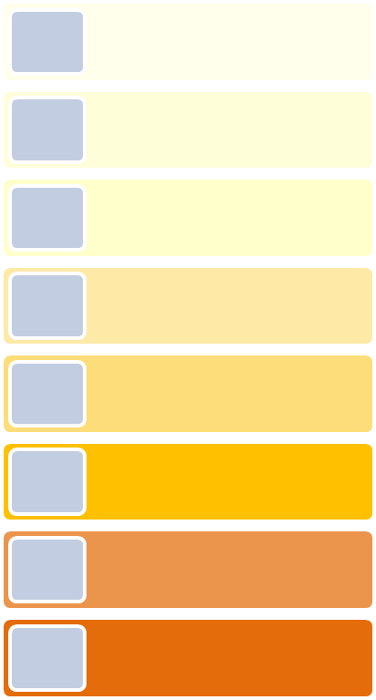

2

**1,2,3 is healthy wee**

Patient NHS number

……………………………………………………………….

……………………………………………….

3

4

**4 to 8 you must hydrate or face the risk of urine infection and sepsis**

GP Practice…………………………………………….

Phone no ………………………………………………

5

6

District nurse phone no

……………………………………………………………….

7

Out of hours contact number

111

81

**CARRY THIS CARD WITH YOU AT ALL TIMES AND PRESENT IT WHEN YOU ATTEND HOSPITAL, YOUR GP PRACTICE OR WHEN YOU SEE YOUR DISTRICT NURSE**

V.1 June 2019



**What colour is your wee?**

**4 to 8 you must hydrate or face the risk of urine infection and sepsis**

**1,2,3 is healthy wee**

**CARRY THIS CARD WITH YOU AT ALL TIMES AND PRESENT IT WHEN YOU ATTEND HOSPITAL, YOUR GP PRACTICE OR WHEN YOU SEE YOUR DISTRICT NURSE**

Patient name

………………………………………………………………

.

GP Practice…………………………………………….

Phone no ……….………………………….............

District nurse phone no

………………………………………………………………….

Out of hours contact number

111

Patient NHS number

………………………………………………………........

